How To Play “Align 4”

**Game Information**

* Players: 2
* Deck used: Standard 52 card deck
* Card values:
  + A: 1
  + 2-10: Number printed
  + J: 11
  + Q: 12
  + K: 13

**Setup**

1. Separate the deck by color (place all hearts and diamonds cards in one pile, and clubs and spades in another), with each player taking one pile.
2. Each player draws 5 cards from their deck to create their starting hand, then places an additional card from their deck face-up in the center of the table, so that one side is touching their opponent’s card.

The game is set up and ready to begin

**Play**

1. The player with the highest valued card on the table goes first.
2. The player must place one card from their hand on the table so that at least one side of the card touches the side of a card already on the table.

Red Player plays the 2 of Diamonds

1. If the card is placed next to at least one of the player’s opponent’s cards, a check must be made for each card.
   1. If at least 2 of the player’s cards touching the opponent’s card add to the exact value of the opponent’s card, the opponent’s card is turned face-down.

After performing the check, Red Player's J is flipped over (8 + 3 = 11, the value of J)

Black Player plays the 8 of clubs

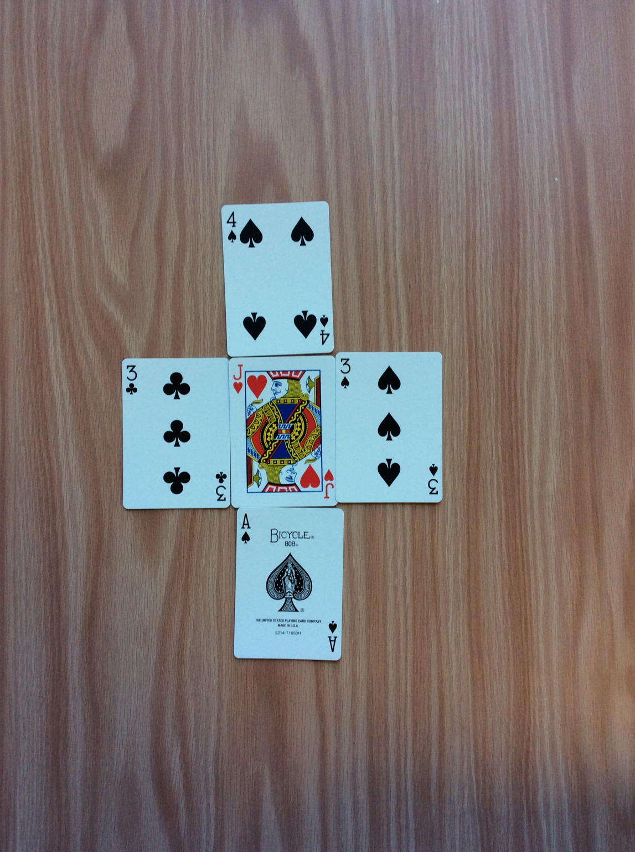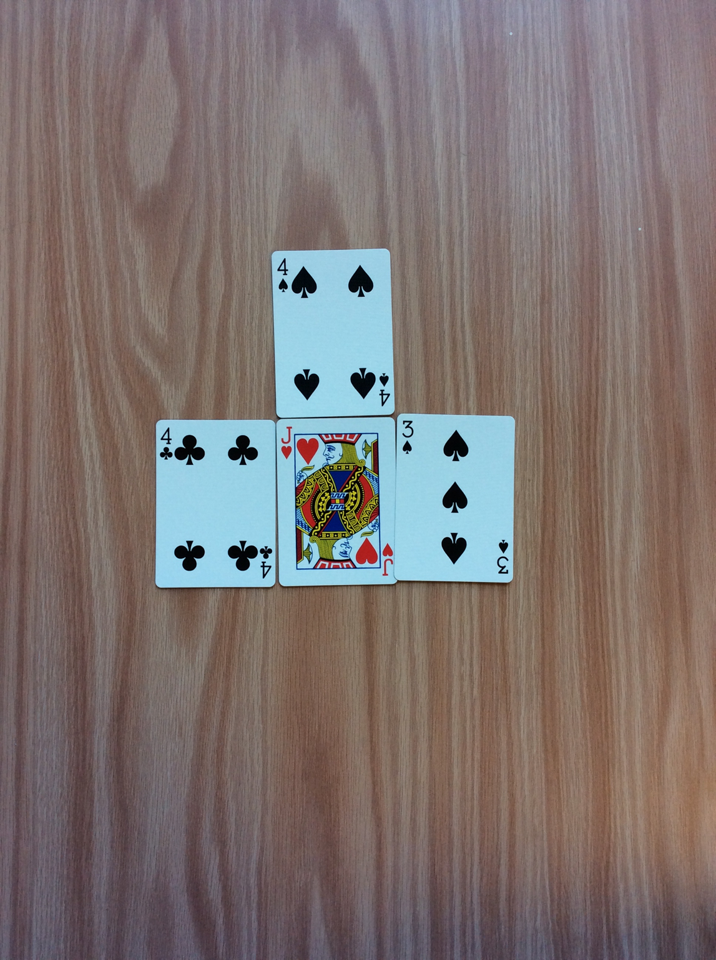(The following would also cause the Red Player’s J to flip)

Using 4 cards to reach the value

Using 3 cards to reach the value

* 1. Flipped cards are considered out of play, and can no longer be used by the player who owned the card.

1. The player then draws a card from their deck.
2. Repeat steps 2-5, switching players each time until one player wins.

**How to win**

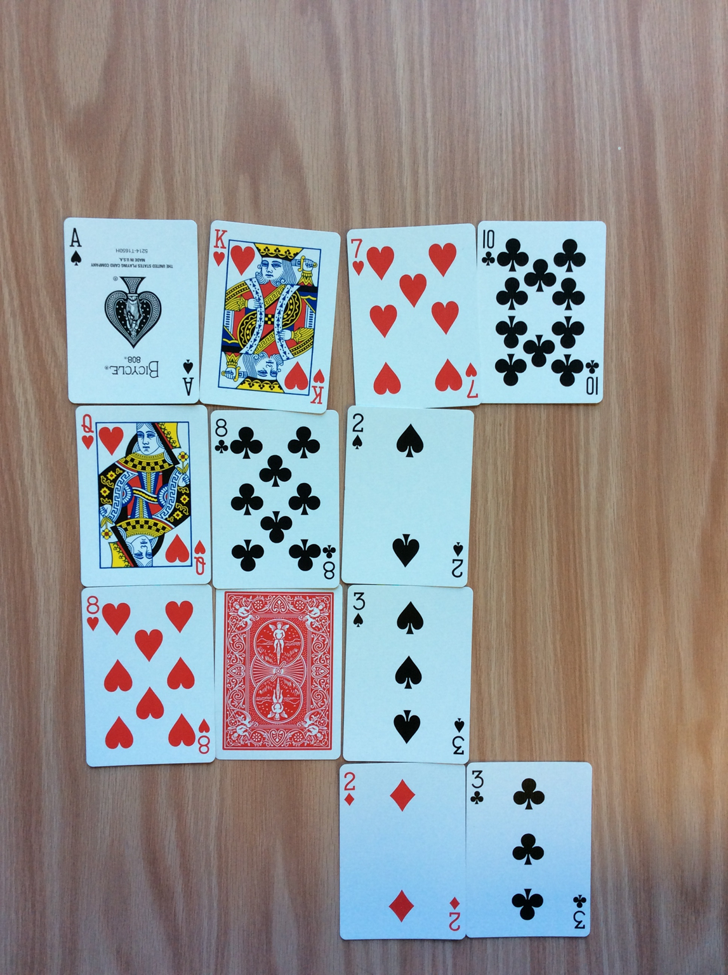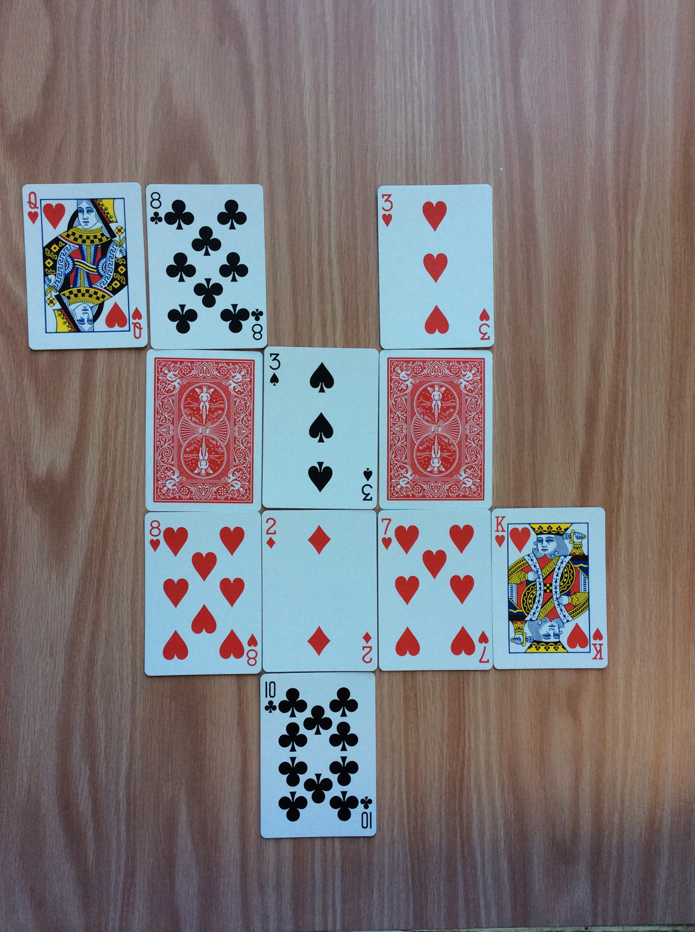A player wins when they place 4 cards of their color in a row horizontally, vertically, or diagonally.

Black Player wins vertically

Black Player wins diagonally

Red Player wins horizontally